ASSIGNMENT – III

DOMAIN: IOT

PROJECT TITLE: Smart Farmer – IOT Enabled Smart

Farming Application

Name: DEVISHREE. N (713319EC020)

ASSIGNMENT TITLE:

Write a python code for blinking LED ad Traffic lights for Raspberry pi.

# Blinking LED:

import RPi.GPIO as GP from time import sleep

GP.setwarnings(False)

GP.setmode(GP.BOARD)

GP.setup(8,GP.OUT,initial=GP.LOW)

while True: #infinite loop

GP.output(8, GPIO.HIGH) # Turn on print("The LED is ON")

sleep(2) # Sleep for 2 second

GP.output(8, GPIO.LOW) # Turn off print("The LED is OFF")

sleep(2) # Sleep for 2 s

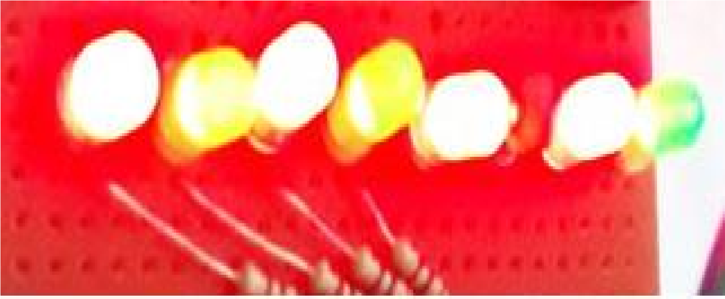

# Traffic Light Controller:

from gpiozero import LED from time import sleep

red= LED(17) #pin numbers connected to Led's aster=(22) green=(27) while True:

red.on() #RED light print("Red light is ON") for i in range(100,0,-1):

print("Remaining time: ",i) sleep(1) red.off()

aster.on() # ASTER light print("Yellow light is ON") for i in range(5,0,-1):

print("Remaining time: ",i) sleep(1) aster.off()

green.on #GREEN light

print("Green light is ON") for i in range(30,0,-1):

print("Remaining time: ",i) sleep(1) green.off()

